Goodbye, Hazel, and Thanks for the Memories

It is with sadness that we share with you the loss of Hazel Pembroke Bassage. Our friend and benefactor passed away on February 16 at the age of 95.

She is survived by her son Lyle and his wife Jean; granddaughters Dawn, her husband Duane Kittleson; and Denise and her husband Scott Bickert. Hazel will be sadly missed by her great-grandchildren, Andy, Rebecca, Caitlin, and Kylie.

We have indeed been fortunate to have had the privilege of knowing Hazel, whether it be in the classroom or in the neighborhood. We would not have a Historical Society if it were not for Hazel and her friends insisting we needed to preserve our past for future generations. Because of Hazel we have a building to house your collections. Because of Hazel we have a complete understanding of who we are and where we came from. We will miss Hazel, her stories, and her tenacity when she set her mind to a project.

We have all benefited from her hard work. It is up to us now to continue her mission of preserving the history of Walworth and telling it to the children. Thank you Hazel, for your wonderful gift to us. We have received several donations in her memory and are grateful to the donors.

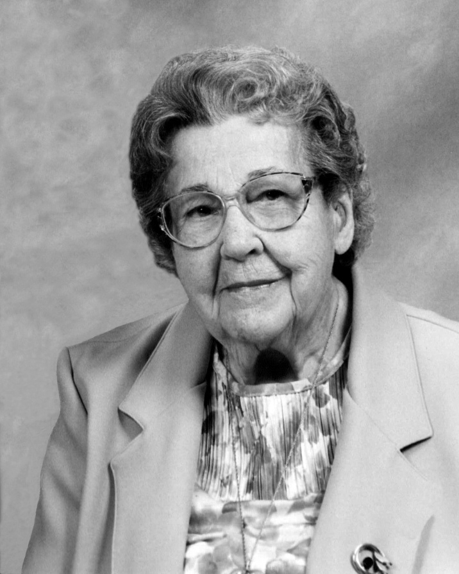
Hazel Bassage

